FMX Mobile Application Development

Lab Exercise 03.06: StyleBook and Working with Custom Styles.

FireMonkey applications automatically load and display the appropriate native style at run time (depending on the target device), without you needing to add a stylebook or any code. Also, FireMonkey applications can have custom styles that display well on high-resolution displays as well as standard-resolution displays. High-resolution styles (such as Retina) are only shown at run time.

Loading Your Own Custom Styles
The Lab Exercise describes working with custom styles, such as the Jet style, which is available in the FireMonkey Premium Style Pack, that you can download from GetIt
http://docwiki.embarcadero.com/RADStudio/en/Installing_a_Package_Using_GetIt_Package_Manager
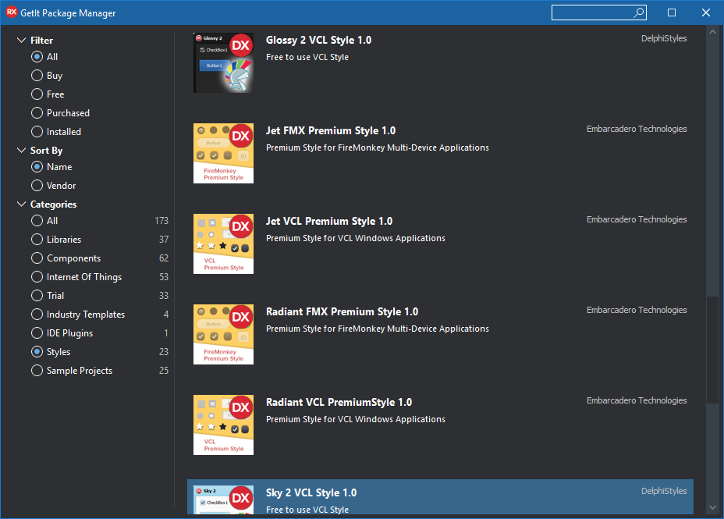
Adding a Custom Style to Your Mobile Application

RAD Studio includes the following custom mobile styles:
- Android:
  - AndroidDark.fsf
  - AndroidLDark.fsf
  - AndroidLDarkBlue.fsf
  - AndroidLight.fsf
  - AndroidLLight.fsf
  - GoogleGlass.fsf
- iOS:
  - iOSBlack.fsf
  - iOSTransparent.fsf

These styles are installed on your system, in the Styles directory, in the following platform-specific directories:
C:\Users\Public\Documents\Embarcadero\Studio\20.0\Styles\iOS
C:\Users\Public\Documents\Embarcadero\Studio\20.0\Styles\Android

The custom mobile styles for iOS and Android include support for standard- and high-resolution devices within one style file. This includes built-in support for:
- iOS standard, iOS Retina devices (1x, 2x) and iOS Retina HD devices (3x)
- Multiple resolutions for Android devices (1x, 1.5x, 2x, 3x)

In addition, you can get new FireMonkey styles that are available in the FireMonkey Premium Style Pack, which also support 3x resolution for iOS 8 devices.

To add a custom style to a FireMonkey multi-device application
- Create a Multi-Device Application.
- With the Master view selected, add a TStyleBook component to your form.
- On the Master view, select a style from the Form Designer Style drop-down menu (Windows, OSX, iOS, or Android). This example uses Android style for the Master view:

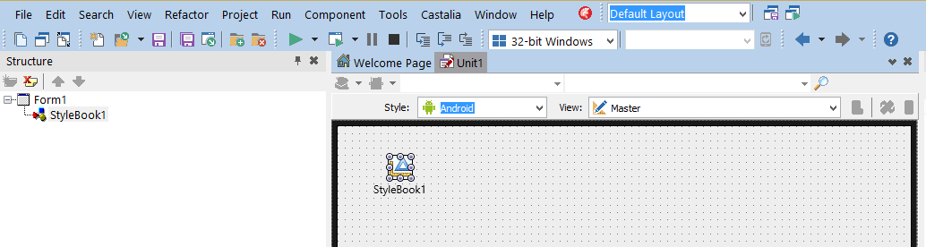
4. Load a FireMonkey style file for the appropriate platform:
  - Double-click the StyleBook. The FireMonkey Style Designer opens.
  - Click the button on the toolbar of the FireMonkey Style Designer.
  - Navigate to the FireMonkey style file you want.
For example, if Android is the Form Designer style set for the current view, you would load and assign an Android style such as AndroidLight.fsf.
Note: The FireMonkey styles for the various Form Designer styles are located in parallel directories:
Windows: C:\Users\Public\Documents\Embarcadero\Studio\20.0\Styles
Android: C:\Users\Public\Documents\Embarcadero\Studio\20.0\Styles\Android
iOS: C:\Users\Public\Documents\Embarcadero\Studio\20.0\Styles\iOS

5. Switch to each of your created views, select the TStyleBook component in that view, and load the custom style related to that platform. When working with custom FireMonkey styles, each view, including the Masterview, must have a style assigned in the Form Designer.
That is, load a Windows style for the "Windows Desktop" view, an Android style for the "Android..." view, a Mac style for the "OS X Desktop" view, an iOS style for the "iPad" and the "iPhone" views.
Note: If you have different views for iPad and iPhone, you need to load the same iOS style for each view.

6. To use the custom style instead of the native style on a form, you need to assign the stylebook you want to use to the form at design time:
- On the StyleBook property of the form, select the StyleBook to apply from the drop-down menu.
- Note: See Using Custom Styles on Multiple Forms to learn how to apply a specific custom style to multiple forms without editing the StyleBook property of each form.

Using Custom Styles on Multiple Forms
To apply the same custom style to all the forms of an application, instead of doing it at design time setting the StyleBook property of each form, you can do it at run time using the UseStyleManager property.
To use the same custom style on all the forms of an application.
- Place the TStyleBook component on the main form.
- Set the UseStyleManager property on the Object Inspector to True
- Double-click the StyleBook to open the FireMonkey Style Designer and load the style.

Using Custom Styles on Controls in Multiple Forms
An application may have more than one TStyleBook object, then different forms may use the StyleBook property to reference any of these stylebooks, one at a time. Notice that controls in any form can always use the StyleLookup property to specify any custom style defined in any TStyleBook object used in the current project group.

